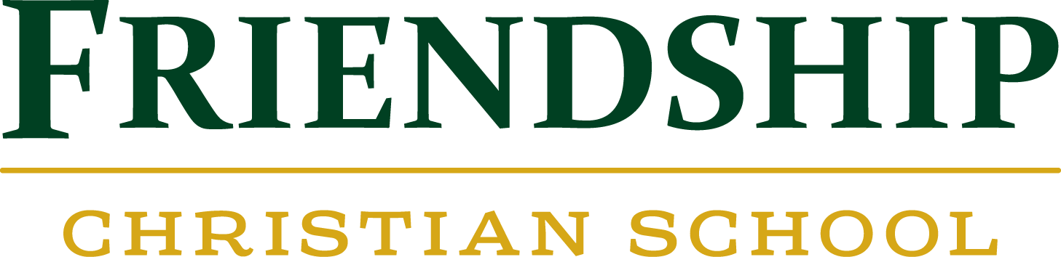

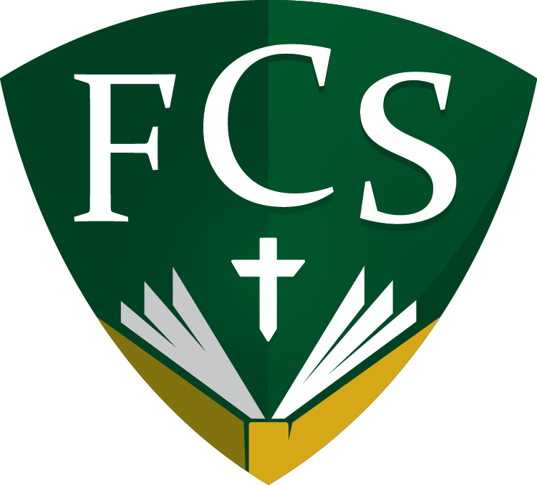

Standard of Dress 2019-2020

5510 Falls of Neuse Road

Raleigh, NC 27609

Phone: 919-872-2133

Fax: 919-872-7451
www.friendshipchristian.net

Rationale for FCS Standard of Dress

Scripture does not stipulate how we should dress. However, God's Word does call us to be imitators of God {I Cor. 11:1), to be modest in our appearance (I Tim. 2:9), to do things in an orderly fashion (I Cor. 14:40), and to bring honor to Him (I Cor. 10:31). A standard of dress demonstrates one way Friendship Christian School meets these commands. Research indicates a dress standard creates an environment conducive to learning and fosters self-esteem in students. The purpose in our standard of dress is to establish a high benchmark of modesty, decorum, and academic excellence.

In an effort to standardize and simplify our school dress the following items are permitted. Any deviation from the standard is not acceptable. Elementary school students whose dress does not meet the standard will earn a tally; a notice will be sent to the parents. Middle and high school students whose dress does not meet the standard will be provided a change of clothing for the day and will incur demerits following the handbook. The borrowed clothing should then be laundered and returned the next school day to avoid fees.

The standard of dress for Dress Down Days allows students to wear loose-fitting, hole-free jeans or athletic pants along with an appropriate shirt. While loose-fitting t-shirts are acceptable, t-shirts with inappropriate graphics or language will not be permitted.
Below is a list of Dress Down occasions:

- Walk Event or Color Run (as directed by Head of School)
- Class events (Community service days or other volunteer work days)
- Monthly Dress Down (fundraisers for junior and senior classes)
- Spirit Days—follow the theme of the day in order to dress down
- Summer Reading Contest reward days
- Other special days as determined by the Administration

Female Kindergarten- 5th Grade | Standard | Example
Blouse/Tops | - Fit: Loose  - Neckline: to the collarbone  - Sleeves: capped, short, long  - Sleeveless: may be worn if the garment has a shoulder width of 3  inches  - Back: cover from top of shoulder to waist  - Between the neckline and the hemline, no skin may show at any  time  - Sheer, lacy, or camouflage not  permitted | 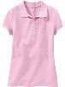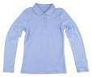
Definition of Term
Loose- of clothing: not fitting close to your
body: not tight
(Merriam-Webster, 2015)
Graphics (applies to shirts, sweaters, hoodies with collared shirt, and sweat shirts with collared shirt) | - The only acceptable writing and printing on clothing are appropriate name brand logos,  college, professional sports, witness wear, or FCS wear. Shirts with slogans and verbiage are not permitted. Graphics will be acceptable as long as they do not conflict with Biblical  principles.
Dresses | - Fit: loose  - Length: to the knee  - Neckline: to the collarbone  - Sleeves: capped, short, or long  - Sleeveless: may be worn if the garment has a shoulder width of 3 inches  - Back: cover from top of shoulder to waist  - Fit: loose  - Leggings: may be worn under | 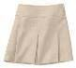  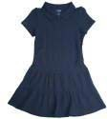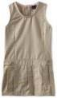
Definition of Term
Loose- of clothing: not fitting close to your
body: not tight
(Merriam-Webster, 2015)
Skirt
Definition of Term
Loose- of clothing: not fitting close to your
body: not tight | skirt or dresses of proper length  but are not to be worn as pants.
(Merriam-Webster, 2015)
Pants/Capri pants/Shorts  Definition of Term  Loose- of clothing: not fitting close to your body: not tight  (Merriam-Webster, 2015) | - Fit: loose  - Cotton/Twill blend  - No holes or frays  - Knee length or longer  - Tan, navy, black, brown, grey | 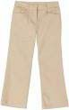
Footwear | - Sandal with heel strap  - Enclosed shoe  - No plastic/beach-wear flip flops  - Cute sneakers are great! | 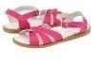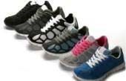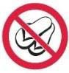
Hair Hats/Headwear  Make-up  PE Class (3rd-5th grades) | - Natural colored hair  - Conventional style  - May not be worn in the school building  - Make-up is not permitted (natural lip gloss is acceptable)  - FCS PE Uniform required

Male Kindergarten- 5th Grade | Standard | Example
Kindergarten - 5th Grades Shirts | - Collared shirt  - Appropriately buttoned  - Sleeveless shirts are not permitted | 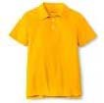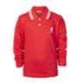
Sweaters | - Permissible without collared shirt | 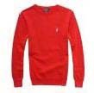
Graphics (applies to shirts, sweaters, hoodies with collared shirt, and sweat shirts with collared shirt) | - The only acceptable writing and printing on clothing are  appropriate name brand logos, college, professional sports, witness wear, or FCS wear.  Shirts with slogans and verbiage are not permitted. Graphics will be acceptable as long as they do not conflict with Biblical  principles.
K- 5th Grades Pants  Shorts | - Fit: loose  - Cotton/Twill blend  - No holes or frays  - Worn at the waist line  - Length: to the knee  - Cotton/Twill blend | 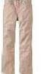  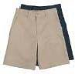
Footwear | - Enclosed shoe with socks  - No flip flops | 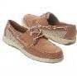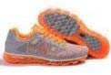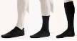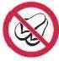
Hair | - Combed neatly  - Should not touch eyebrows, ears, or collar of shirt | 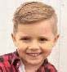
Hats/Headwear  Body Piercing  PE Class (3rd-5th grades) | - May not be worn in buildings during school hours  - May not wear earrings or similar adornment  - FCS PE uniform required

Female Students  6th ₋ 12th Grade | Standard | Example
Blouses  Definition of Term  Loose- of clothing: not fitting close to your body: not tight  (Merriam-Webster , 2015) | - Fit: loo se  - Neckline: to the collarbone  - Sleeves: capped, short, or long  - Sleeveless: may be worn if the garment has a shoulder width of 3  Inches; no undergarments showing  - Back: cover from top of shoulder to waist  - Between the neck line and the hemline, no skin/undergarments may show at any time  - Sheer, lacy, or camouflage not permitted
Graphics  (applies to shirts, sweaters, hoodies with collared shirt, and sweat shirts with collared shirt) | - Not permitted on regular school days  - Logos should be small  - Dress Down Days: Graphics will be acceptable as long as they do not conflict with Biblical principles. College and team graphics are fine on Dress Down Days.
Dresses | - Fit: loose  - Length: to the knee (within 2 inches of the crease at the back of the knee)  - Neckline: to the collarbone  - Sleeves: capped, short, or long  - Sleeveless: may be worn if the garment has a shoulder width of 3  inches; no undergarments showing  - Back: cover from top of shoulders to waist  - Fit: loose  - Length: to the knee (within 2 inches of the crease at the back of the knee)  - Slits: must be below the knee  - Leggings may only be worn under skirts or dresses of proper length  - Sheer, lacy, or camouflage not permitted
Definition of Term
Loose- of clothing: not fitting close to your
body: not tight
(Merriam-Webster, 2015)
Skirts
Definition of Term
Loose-of clothing: not fitting close to your
body: not tight
(Merriam-Webster, 2015)
Slacks  Definition of Term  Loose- of clothing: not fitting close to your | - Fit: loose  - Cotton/Twill Blend  - No denim jeans  - No holes or frays  - Tan, navy, black, brown, or grey  - No skinny pants  - Ankle-length (within inches of ankle) | 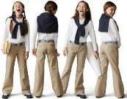
body: not tight
(Merriam-Webster, 2015)
Undergarments | - Proper undergarments must be worn at all times and should be completely  hidden
Footwear | - Enclosed shoe (tennis shoes or deck shoes, etc.)  - Sandals  - High heels should not be higher than 2" | 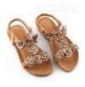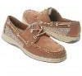
Hair | - Natural colored hair  - Conventional sty le  - No body piercing other than ears; maximum of two ear piercings  - May not be worn in buildings during school hours  - No tattoos
Body Piercing
Hats/Headwear
Tattoos
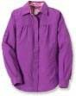
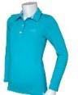

Male Students  6th - 12th Grade | Standard | Example
Shirts | - Collared shirt  - Appropriately buttoned  - Camouflage not permitted | 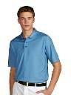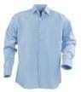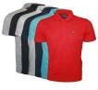
Sweaters | - Permissible without collared shirt | 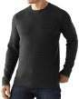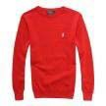
Graphics (applies to shirts, sweaters, hoodies with collared shirt, and sweat shirts with collared shirt) | - Not permitted on regular school days  - Logos should be small  - Dress Down Days: Graphics will be acceptable as long as they do not conflict with Biblical principles.
6th - 12th Grades | - Fit: Loose  - Cotton/Twill blend  - No denim  - No holes or frays  - Belt preferred
Slacks
Definition of Term
Loose-of clothing: not fitting close to your
body: not tight
(Merriam-Webster, 2015)
Footwear | - Enclosed shoe with socks  - No sandals | 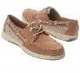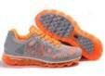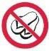
Hair | - Combed neatly  - Should not touch eyebrows, ears, or collar of shirt  - Face is to be clean shaven | 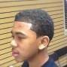
Jewelry  Hats/Headwear Tattoos | - No earrings or body piercings worn on campus or at school related events off campus  - May not be worn in buildings  during school hours  - No tattoos

